­

Sod farms grow turfgrass to be installed elsewhere. Before seeds or sprigs are planted, the soil is tilled and compost is spread. It can take from 10 months to 2 years to cultivate turf before its ready for harvest. Sod is harvested like strips of carpet, taking a layer of soil with it.

SOIL ORIGINS AND CLASSIFICATION

Gold Boundless Bar

Using K&S Sod Farm in St. Cloud, FL, the prominent soil series is Smyrna which is in the order Spodosols. Typical of Spodosols, Smyrna has a small, dark topsoil layer (A) followed by a light-color eluviation layer (E) where the chemicals and organic matter has leached out into the small, darker-colored subsoil (B layer). The parent material, which is sandy marine deposits, is not far down at the C layer. The organic matter percentage lines up with the color of profile, where between 2-2.5% of organic matter is in the topsoil and subsoil.

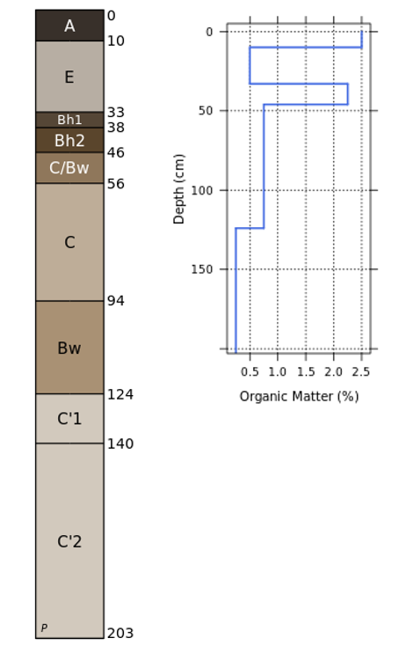

PHYSICAL PROPERTIES OF SOIL

Gold Boundless Bar

The soil texture is mainly sand; therefore, the structure is granular. Smyrma doesn’t drain well and can pond and runoff, although the permeability is rapid in the A and E horizons. The CEC is low in this soil so it won’t hold many nutrients.

MICROORGANISMS IN YOUR SOIL

Gold Boundless Bar

In turf, bacteria is important in breaking down components in thatch. The nitrobacteria perform nitrification, converting ammonium to nitrate for plant use, especially from soil organic matter, as well as slow-release and many quick-release fertilizers. Actinomycetes are more prevalent in high pH soils and are important in lignin breakdown. Fungi are most dominant in acidic soil and improve soil aggregation and structure by physically binding together soil particles.

How to increase microorganisms:

* Make sure you have a well-aerated, non-compacted soil so aerobic microorganisms have plenty of oxygen
* Lime acidic soils to increase bacterial populations

EFFECT OF CLIMATE CHANGE

Sod farms require a lot of irrigation in order to have a healthy crop. Climate change can increase the amount of droughts, increasing the need for water. If they are not able to water the sod, the crop will become thin and soil can erode. Sod farms need to conservatively use the water in order to better preserve it.

IRRIGATION

Gold Boundless Bar

Irrigation is commonly done using a sprinkling system. Sod farms may use portable systems such as the wheel move system shown here or solid-set systems such as rotary sprayer pop-ups.

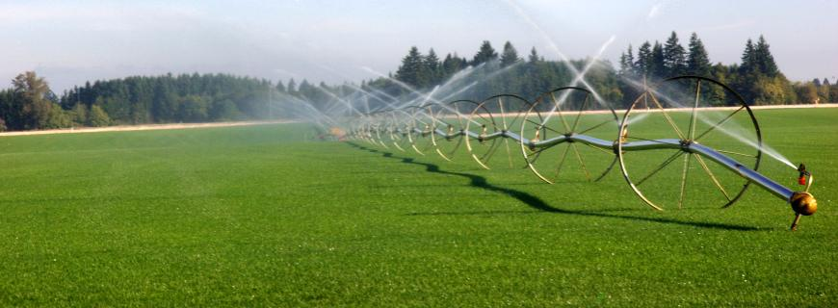

­

WATER NEED AND SCHEDULE

Gold Boundless Bar

For newly planted sod or sprigs, apply a ½ inch of water split into several brief applications of water since the roots are short. For more established turf, monitor the sod on a regular basis to assess the need for irrigation. Apply ½ to ¾ inch of water the following morning if the lawn appears dry. This applies water to the top 8 inches of soil where the majority of roots are. Water deeply and infrequently.

KNOWING WHEN TO WATER

Gold Boundless Bar

Water need can be determine by observing if the sod has a bluish hue. The turf blades will also curl inward when too dry. Another method involves walking on the sod and seeing if the footprints in the sod do not bounce back.

SOIL pH

Gold Boundless Bar

Lime may be needed if the soils have a pH of 5.0 or less. For St. Augustinegrass, liming to a pH of 6.5-7.0 should be done prior to sod production to reduce nutrient leaching. The most common materials for liming sod are calcitic and dolomitic limestone. Use dolomitic limestone when a soil test indicates that magnesium is low.

FERTILIZER RECOMMENDATIONS

Space broadcast fertilizer applications uniformly over the growing season. For Central Florida, apply a complete fertilizer in February and September. For St. Augustinegrass low in phosphate and potash, annually apply 260 pounds/acre of nitrogen,60 pounds of phosphate, and 160 pounds of potash.

HOW TO DO A SOIL SAMPLE

Gold Boundless Bar

Get a representative soil sample by taking 15-20 small plugs at random over the area. Limit your sampling depth to 4 inches since that is where the roots are. Mix the soil plugs and send 1 pound of mixed sample to the UF/IFAS Extension Soil Laboratory and a sample bag from the extension office.

NUTRIENT DEFICIENCIES

Gold Boundless Bar

Iron Deficiency: If phosphorus is excessive or the pH is high, the blades may take a yellow appearance. Although a long-term approach should be taken to correct the cause, a foliar iron chelate (such as iron sulfate) can be applied to quickly enhance the turf color between the spring and summer fertilizer applications.

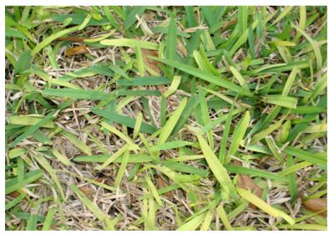

Manganese deficiency can offer on high pH (above 7.0) soils or where high pH water is applied, appearing as yellow blades. Apply soluble or chelated manganese to green-up the grass.

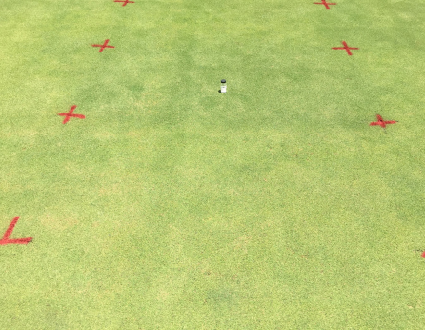

Nitrogen Deficiency: Yellowing is also caused by nitrogen deficiency which provides the building blocks for turfgrass growth. Apply nitrogen fertilizer to correct the deficiency.

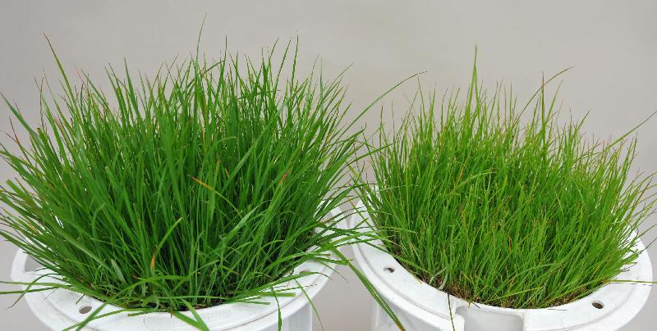

REFERENCES

Gold Boundless Bar

Cooper, R. (1996, Nov). *Soil microorganisms: A turf’s manager’s guide.* GCM Online. <https://www.gcmonline.com/course/environment/news/soil-microorganisms-soil-microbes-turfgrass>

Hale, T. C., & Burgess, C. (2018, Aug). *St. Augustinegrass yearly maintenance program.* Clemson University Extension. <https://hgic.clemson.edu/factsheet/st-augustinegrass-maintenance-calendar/>

Shaddox, T.W. (2016, Dec). *Fertility Considerations for Sod Production.* UF/IFAS EDIS. <https://edis.ifas.ufl.edu/publication/SS164>

SodLawn. (2020, Apr). *How sod farms grow grass.* <https://sodlawn.com/how-sod-farms-grow-grass/>

UC Davis California Soil Resource Lab. (2021, Nov). *SoilWeb.* <https://casoilresource.lawr.ucdavis.edu/gmap/>

Trenholm, L. E., Schiavon, M. Unruh, J. B., Shaddox, T. W., & Kenworthy, K. E. (2021, Aug). *St. Augustinegrass for Florida lawns.* UF/IFAS EDIS. <https://edis.ifas.ufl.edu/publication/LH010>